**Movie Ticket Purchase:**

Using Vue.js create the ability for a user to choose movie tickets for at least 3 movies, for either/both child and adults.

**Overall Project Requirements:**1) Site must LOOK PROFESSIONAL! After all this is a WebDev II class!

2) Hardcoding of movies should be avoided – like the plague. For example, if your code allows for three movies and I change that to 4 while grading, the cart should JUST WORK. No recoding should be necessary. (Within reason. I understand your code layout may look best with 3 movies, and when I change your ajax object to work with 8 movies, things look caty-wompus. This is not what I am referring to)

3) All shopping cart functionality should be done using vue.js. NO PAGE RELOADS or form posting is used to complete this project.

4) Be as efficient with your code as possible. If you see yourself repeating code – find another way.

**Requirements for the shopping cart data:**

1. Movies will be data received from the Movie DB API. <https://www.themoviedb.org/documentation/api>
2. Using an asyncrounouse call – obtain at a minimum three items from one of the categories below. For example, 3 movies from the NOW PLAYING category.
   1. You are required to get the **title**, the **description** and the **image**

• Top rated movies

• Upcoming movies

• **Now playing movies**

• Popular movies

• Popular TV shows

• Top rated TV shows

• On the air TV shows

• Airing today TV shows

1. Display the returned Json data using VUE.
2. Provide a way for the user to choose either a child’s ticket or an adult’s ticket from each movie/tv category
3. Once a user selects a minimum of one ticket – the shopping cart subtotals/totals should display

**Shopping Cart Summary:**

* Subtotals:
  + Qty of childrens tickets purchased per movie
  + Qty of adult’s tickets purchased per movie
  + Subtotal of children and adult tickets per movie
* Totals:
  + Total of Adults tickets purchased (qty and price)
  + Total of Children’s tickets purchased (qty and price)
  + Combined Total of all purchased tickets (qty and price)

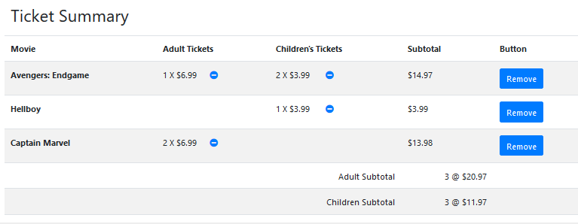

Shopping Cart Functionality:

* User should be able to decrease the adult tickets or children’s tickets purchased
* User should be able to delete an entire movie purchase
* If an item qty is zero – it should not be displayed (for example no children’s tickets shown below)

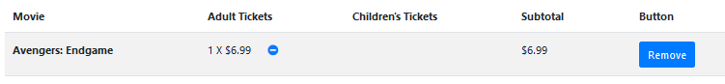

* If no tickets are purchased yet, the Ticket Summary should not show

Screenshots of examples below:

My Example Screenshots  
